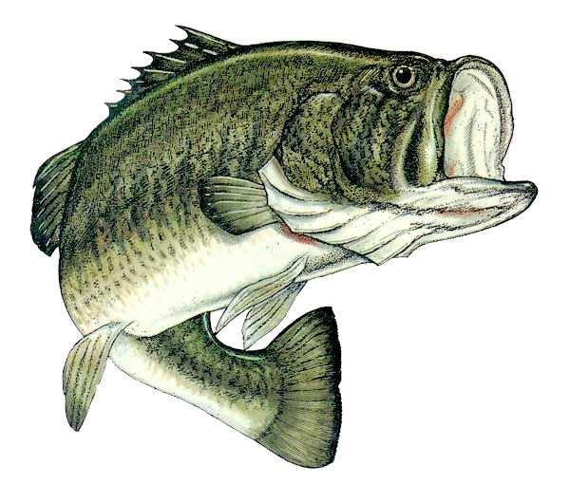

WeekendBassers

Rules and Regulations

**PREFACE:** The following rules for the season will be interpreted solely by the club officers. Any announcements made by the club officers at the tournament site take precedent over written rules. Any situations arising during a tournament that are not covered by the following rules will be addressed by the club officers present.

**DUTIES OF OFFICERS**

**President:** To preside over tournament moneys, decisions, and classic escrow.

**Tournament Director:** To assist the President in all aspects of responsibility and to acquire tournament exemptions in a timely manner and file needed reports of tournament results to the Florida Game and Fish Department.

**TOURNAMENT FEE BREAKDOWN:**

Tournament Fee’s:                  $70.00 Per Boat, $100.00 Per Boat for 2 Day Tournaments

Entry:                                      $38.00 Per Boat, $48.00 Per Boat for 2 Day Tournaments

End of Year Classic:                $15.00 Per Boat, $25.00 Per Boat for 2 Day Tournaments

Big Fish of Day:                      $12.00 Per Boat, $22.00 Per Boat for 2 Day Tournaments

Angler of the year  $ 2.50 per boat

Big fish of the year $ 2.50 per boat

Pay Outs:                                 1st Place:   50%

                                                2nd Place: 30%

                                                3rd Place:   20%

                                                Big Fish:   100%, 50% Day 1 Big Fish, 50% Day 2 Big Fish for

2 Day Tournaments

Club dues will be held in escrow by the Club President and/or Tournament Director until the end of year classic.

Classic Tournament entry fee will be in the same fee structure as above to include escrow collected throughout the tournament trail year.

Classic payouts will be determined by WeekendBassers officers.

**Note: WeekendBassers will be hosting only one classic group of participants and qualification is as follows:**

**CLUB RULES:**

1. By participating in any tournament conducted by WeekendBassers, it is understood that the following club/tournament rules have been read, agreed on, and shall be adhered to.
2. Club Dues will be $50.00 per person, per year, must be paid prior to participation in **ANY** tournaments.

Additionally, kids 12 and under may fish as a 3rd member of the team and no extra membership or tournament dues are needed.

1. **At least one (1) team member must fish at least Eight (8) Tournaments to be eligible to fish the WeekendBassers classic.** In the event your regular partner is unable to participate in the year end classic, your alternate partner who fished during the season and has become a paid member can substitute for the classic.
2. 11 tournaments will be fished for points towards *angler of the year and wb classic hotel accommodation credits.* Teams will receive 100 participation points for attending each regular season tournament to reward those teams that do participate. Participation points will be included towards end of the year points.

Points will be assigned for total weight less any dead fish penalty at the rate of 100 points multiplied by total poundage weighed. Example: Total fish weight = 15.17 lbs. = 1,517 points.

1. Each team is allowed One (1) alternate partner within the year in the event your regular partner is unable to participate.The Alternate will not have to pay the club dues for the first tournament they fish. Club dues are due for the alternate prior to them fishing any more tournaments.

1. Teams who have met the requirements to fish the classic will receive one night of hotel accommodations at our WeekendBassers classic. The Classic will be a two-day tournament at a place TBD by the tournament director with input from the President as required. N**o pre-fishing / scouting will be allowed prior to the Classic** **and no post-fishing / scouting after the first day weigh in!**  However, Weekend Bassers tournament officials are permitted to observe the water due to safety and navigational concerns. Take Off at the classic will be determined by club standings after the 11th tournament of the year.
2. In the event a team should split in the middle of the year, both new teams formed will receive one half of the original teams points at the time of the split unless the original team members agree to a different percentage split not to exceed the original teams total points prior to the split. Only one split per year.
3. No tournament dates will be altered or changed in any way without a majority vote, unless, at the sole discretion of WeekendBassers officers, a complete cancellation of a tournament is deemed necessary due to an unforeseen event or any condition that could endanger the majority of participants.
4. No officer shall hold any one office for more than two (2) years consecutively, subject to vote.
5. An available majority of members at the Classic shall elect by vote the next year’s President and Tournament Director.
6. All rules are subject to change by Senior membership committee, President, and Tournament Director as they deem fit for the betterment of WeekendBassers. (Used for one off situations, emergencies etc.)

**TOURNAMENT RULES:**

1. Each angler is required to wear a Coast Guard approved life vest at all times the combustible engine is running. If the participants choose not to, under no circumstance is the club or its officers liable for any resulting risk incidents.
2. Kill switches must be used and proven functional in all boats. To the extent that your kill switch does not operate properly, under no circumstances is the club or its officers liable for any resulting risk incidents.
3. Each boat must be properly registered and have all required Coast Guard safety equipment. In addition, it must have a functional livewell space, properly aerated to adequately maintain a live limit of all fish caught during the tournament.
4. Navigation lights must be used at the start of each tournament and remain on until the shoreline, on the opposite side of the lakes becomes easily visible.
5. Safe boat conduct must be observed at all times.
6. Tournament begins at safe light. Tournament Director makes the determination when/what safe light is. Takeoff will be determined by a random draw at the time of payment prior to the tournament at the ramp. For two day tournaments, day two takeoff will be determined by reversing the day one takeoff order. 3:00pm is the official finish time for the tournaments with the exception of June, July, August, and September which will be at 2:00pm. Day two of a two day tournament will be at 2:00pm. No early weigh in allowed. However, weigh in time is subject to vote prior to tournament start. Lateness, with the exception of breakdown, means disqualification.   Any boat not accounted for by 15 minutes after weigh in time will be disqualified and searched for.  One pound per minute late will be deducted (up to 15lbs.). If any boat leaves a tournament early they must contact the Tournament Director or President to notify them.
7. Five (5) fish, per boat may be entered.  Only LARGEMOUTH BASS will be weighed unless otherwise noted by tournament director before the applicable tournament.  A member fishing alone may weigh five (5) fish as well (unless otherwise determined by tournament officials or F.W.C regulations). All live fish must be released on site. A ¼ (.25) pound penalty will be imposed for each dead fish and deducted from total weight. This does not pertain to big fish. (i.e. a ¼ pound is not deducted from big fish weight).
8. You are allowed to bring a maximum of five (5) fish to the scale per boat. If the amount of fish at the scale exceeds this limit it will be a disqualification of the days tournament and zero (0) points will be given.
9. In the event of a tie for overall tournament, the tied team’s big fish will determine the tiebreaker. in the event neither team weighed a big fish, the prize money will be split 50/50. Ties for Big Fish shall split the Big Fish money 50/50.
10. No culling of fish will be allowed at the weigh in site. It must be done before entering the location of which the tournament was started or staged from.
11. Livewells must be made available for search to tournament officials upon request prior to the start of any given tournament.
12. No one is allowed to leave his or her boat except for an emergency.
13. A boat seen with the trolling motor up and the anchor down or trolling motor down shall not be approached within 50 feet unless invited.
14. Only Casting, Spinning, or Spincasting rods may be used. Any other type of rod or reel is prohibited. Numerous rods may be rigged and ready to use, but only one rod per person is permitted to be in use at any one time.
15. No trolling is allowed.
16. Fishing is only allowed in waters accessible to all fishermen.
17. Only artificial lures may be used. No live or prepared baits may be used with the exception of commercial pork rinds.
18. All fish must be caught live and in a sporting manor. Anyone found guilty of snatching or snagging visible fish will be disqualified.
19. When fishing for bedding fish, fish must be hooked inside the mouth to be a legal fish.
20. Every attempt shall be made to land a fish in a manner that will not harm the fish and allow for a live release. The use of a landing net is allowed to boat a fish.
21. The use of cell phone or radio will be limited to emergencies only, not to help in the location of fish from one team to another.
22. Any member who receives a prize may be subject to a polygraph test and shall forfeit any prize or points for refusal.
23. Protests of violations of the tournament rules may be made to the Tournament Director at any time during the tournament or weigh in, but must be made within 15 minutes of the final fish being weighed. Protests made more than 15 minutes after last fish weighed in will not be considered.